Carlie Jansen Memorial Scholarship
Rejoice always, pray continually, give thanks in all circumstances;
for this is God’s will for you in Christ Jesus.
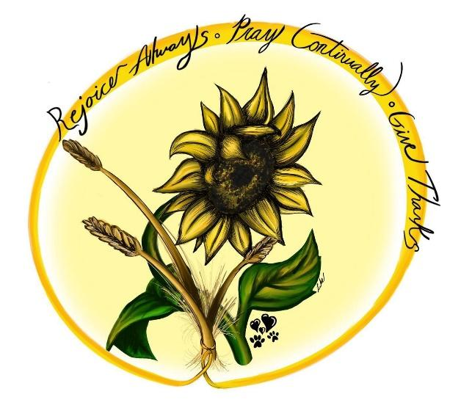
(I Thessalonians 5:16-18)
This scholarship is dedicated to a loving and caring former CWC Art Teacher, who passed away in 2021. Carlie’s life experiences gave her the love and passion for community. Everyone who entered her classroom felt her enthusiasm for art and her love for life. More than that, students were impacted by her desire to talk to them about their faith and impact their Christian walk, as was done for her while being part of both the Dordt University and CWC family! Carlie’s family would love to honor her name by helping other CWC young people experience the blessing of Dordt while pursuing their post-secondary education.
Central Wisconsin Christian seniors that have chosen to attend Dordt University and desire to live life as stated in 1 Thessalonian 5:16-18 are all encouraged to apply for this annual award. Carlie also had a dream to teach and primarily to teach art, therefore those also may be considerations in honoring her with this scholarship. This is a $3,000 award for the freshman year of study, with half of the funds distributed at the start of the first semester and the second half at the onset of the second semester of enrollment.

Name: GPA:
Intended Major/Course of Study:

Attached the following to this application:
- An essay that describes how you have pursued and continue to strive to display Carlie’s life verse - 1 Thessalonians 5:16-18.
- An essay that describes how a Christian Education at CWC has impacted your life.

