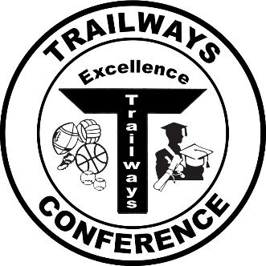 **Duane Bark Memorial Scholarship**

Life is not something to be taken for granted, and neither is health and the ability to participate in student activities. The pandemic has provided all of us an important lesson to treasure each day we have and each opportunity we are blessed with to sing, act, play, run, throw, and be together with our classmates. These opportunities were at the heart of the personal and professional life of Duane Bark, whose life was cut short by COVID-19 in October of 2020.

Duane’s life was dedicated to helping kids grow, serving for nearly four decades as a teacher, administrator, coach, leader, and mentor. His greatest mission in life was to help others reach their fullest potential, leaving a wave of influence behind him. A man of faith, his example was genuine and heartfelt, and his legacy one of love and dedication to his family, his students, his school, his community, and anyone who needed to be lifted up.

There are two $500 scholarships available, one for a male and one for a female student who will be a graduating senior from a member school of the Trailways Conference. This scholarship recognizes the gifts of students in the areas of athletic leadership, positive influence toward other students, and living out Duane’s ideals of faith, love, and dedication.

Evaluation of applicants will be completed by a Trailways Conference Scholarship Committee. These are annual awards granted to graduating seniors and used for the second semester of their continuing education. The application deadline will be April 1, with the recipients announced by May 1.

**Name:**

**High School Attended:**

**Address:**

**City/State/Zip:**

**Email**:

Attach an essay to this application that includes answers to the following questions:

* What are your intended post-high school educational plans (school/field of study)?
* What are your career goals, both short-term and long-term?
* Explain how you lead and influence others, making a positive impact on your school’s culture through Mr. Bark’s ideals listed above.
* How will you take the lessons/experiences you have had participating in school activities into your future?

Include two letters of recommendation, one from someone who can comment on your leadership, the second from someone who can verify your work ethic and dedication. One of these should be from a non-faculty member.

I have read and understand the criteria for the Duane Bark Memorial Scholarship.

Signature ___________________________